Contents
1. Introduction 2
2. Technology Used 2
3. Pages and Features 2
3.1 Home Page 2
3.2 Upload MRI Page 3
3.3 Results Page 3
3.4 About Page 3
3.5 Privacy Policy & Terms Pages 3
4. Navigation 3
5. User Interface and Experience 3
6. Interaction with Backend 4
7. Conclusion 4

MRI Detection & Segmentation App

1. Introduction
This report describes the front-end of an MRI Detection & Segmentation App. The front-end is built using React.js, a popular JavaScript library for creating interactive web applications. The app allows users to upload MRI images, receive AI-based classification results, and view segmented MRI images.
The main goal of the front-end is to provide a user-friendly interface for interacting with the AI model running on the backend.
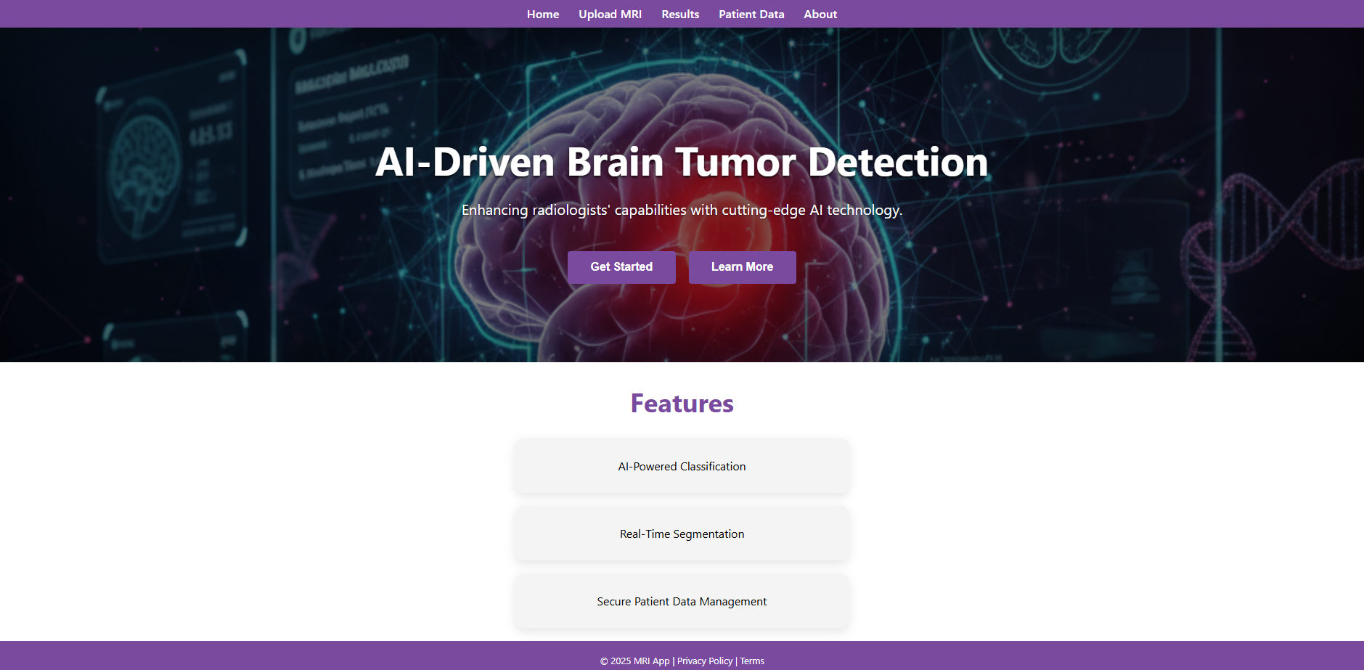

2. Technology Used
- React.js for building the interface.
- CSS for styling each page.
- React Router DOM for page navigation.
- Axios for communication with the backend API.

3. Pages and Features

3.1 Home Page
- Provides an overview of the app and its functions.
- Contains a hero section with the app description and buttons to navigate to Upload and Results pages.
- Features section highlights key capabilities, such as MRI analysis, tumor detection, and segmentation.

3.2 Upload MRI Page
- Allows users to upload MRI images.
- Shows a preview of the uploaded image before sending it for analysis.
- Includes a progress bar to indicate upload status.
- Buttons available for starting analysis or returning to the home page.

3.3 Results Page
- Displays original MRI images, segmented images, and classification results.
- Users can save results or return to the previous page.
- Modal windows are used for additional data input.

3.4 About Page
- Provides information about MRI technology and AI-based analysis.
- Explains how the app automates tumor detection and segmentation.
- Footer includes links to Privacy Policy and Terms pages.

3.5 Privacy Policy & Terms Pages
- Display the app’s legal and privacy information.
- Styled consistently with the About page for uniformity.

4. Navigation
- Navigation bar is present on every page for easy movement between Home, Upload, Results, Patient Data, and About pages.
- Footer contains additional links and copyright information.

5. User Interface and Experience
- Color Theme: Purple for headers and buttons, white and light gray for backgrounds.
- Fonts: Roboto and Arial for readability.
- Layout: Flexbox used for responsiveness and alignment.
- Interactive Elements: Buttons, hover effects, image previews, and modals enhance user experience.

6. Interaction with Backend
- Front-end communicates with a Python Flask backend to send MRI images and receive results.
- The backend returns tumor type, confidence score, and segmented images for display.

7. Conclusion
The React front-end of the MRI Detection & Segmentation App provides a clean, easy-to-use interface. It allows users to upload MRI images, view AI predictions, and access segmented images efficiently. The design is consistent across pages, making the app intuitive and visually appealing for users.

